Customer API :
This application is developed to manage Customer information. It exposes APIs to perform CRUD operations.
Tech Stack:
- Java 1.8
- Spring Boot 2.3
- Redis
- Mongo DB

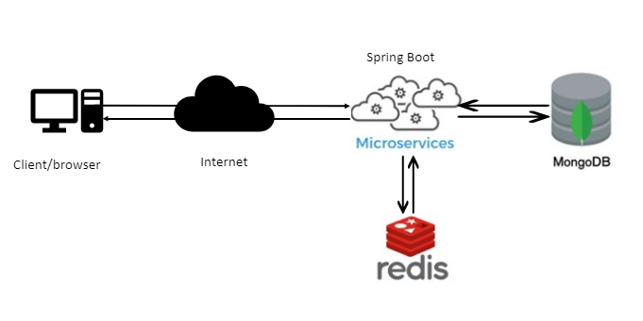
Development Approach:
- Spring Boot is used for the Back-end development as it provides better options to implement microsservices.
- It uses MongoDB for data persistence.
- Redis has been used for better performance (caching).
  - For every fetch operations Redis would be fetched first. If no data found it would be fetched from Mongo DB.
  - Similarly for every update operations, cache would be updated so that fetch will always return updated data.
- Spring AOP(aspect oriented approach) is used for logging. The advantage is to decouple core business logic from cross cutting concerns. This makes our code clean and maintainable.
- Custom Interceptor has been added and configured to implement authorization logic. So the authorization code is placed at one place and called just before the actual API. If request authorized then only it be allowed to proceed further otherwise, unauthorized access exception would be thrown.
By doing so, we are avoiding writing duplicate and boilerplate code.
- Swagger is used for API documentations and It can be accessed on following URL.
URL: http://localhost:8080/swagger-ui.html

